**2019 NYTI Process**

1. Get the Parameter files from PROD environments.
2. Generally, 3 parameter files used for NYTI Run.
3. Parameter Files should place the /AMSROOT/RTFiles/FINSYS/Parms:

**Note:** Since this process has run for FY2019 New year parameter value is 2019 and base year parameter is previous year 2018

1. Before running the job, the parameter should update the NYTI job to every parameter un.

* Batch job setup -> Utilities- > Chain Job- > NYTI Process

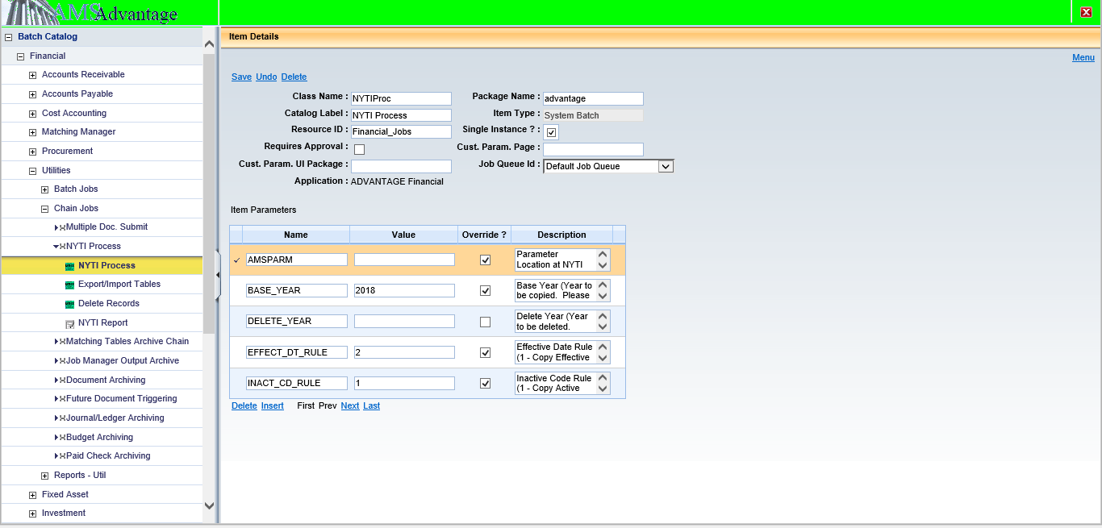

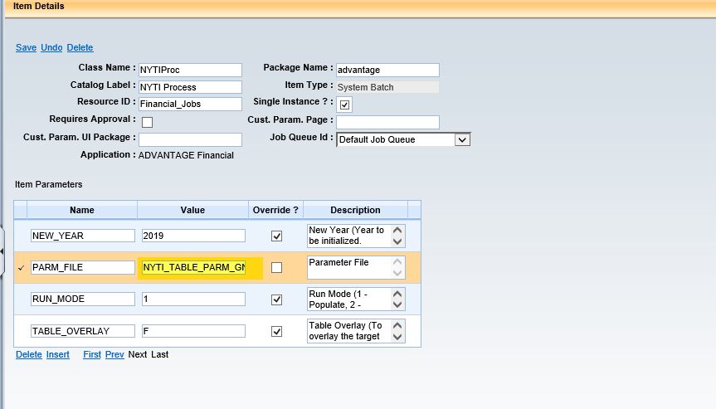

1. Run job with parameter file NYTI_TABLE_PARM_SYS.txt.

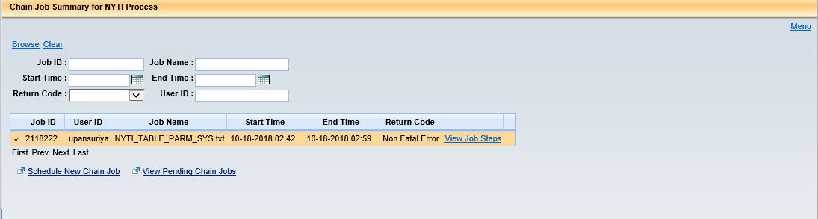

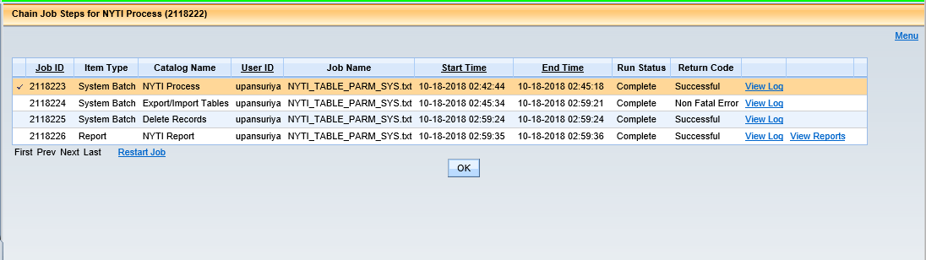

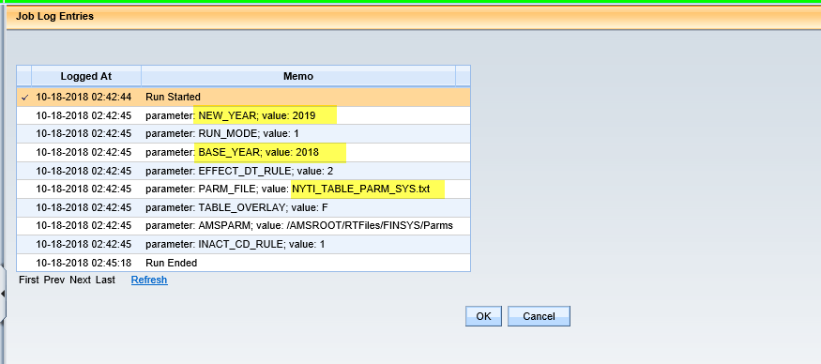

1. Run2: Run the chain with parameter file NYTI_TABLE_PARM_GN_LVL_CNST_SYS.txt

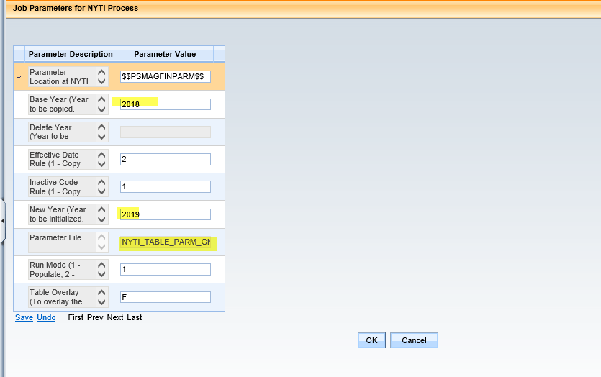

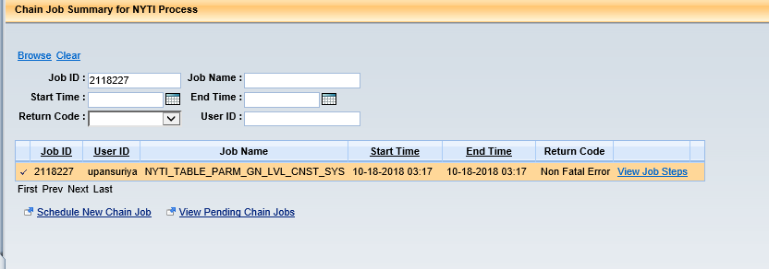

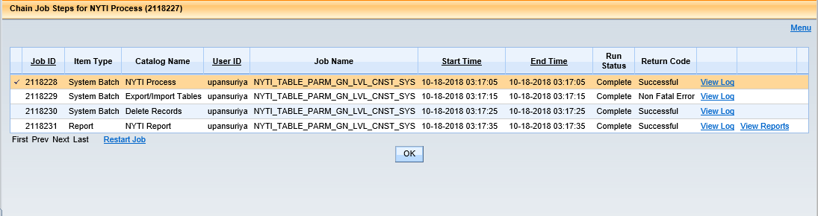

1. Run3: Run the chain with parameter file NYTI_TABLE_PARM_GN_FUND_CNST_SYS.txt

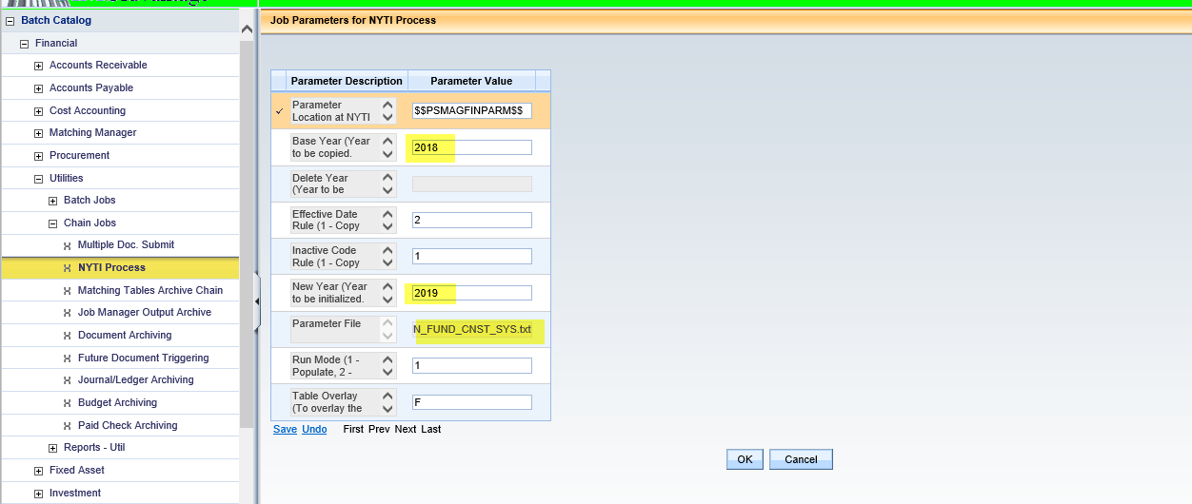

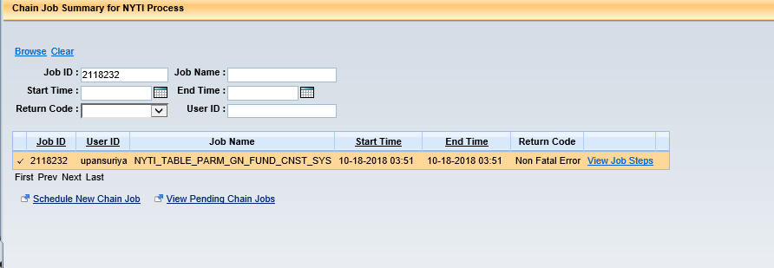

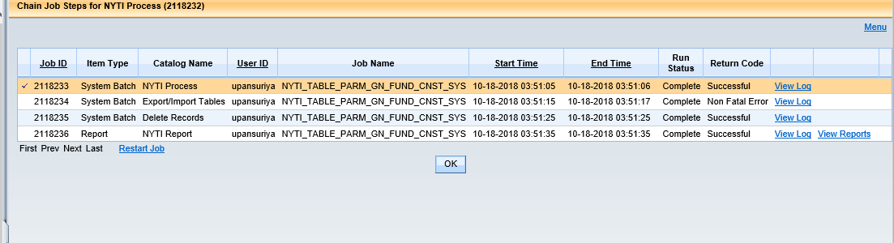

1. check the new year set up in all tables in SYS.

**Fund**

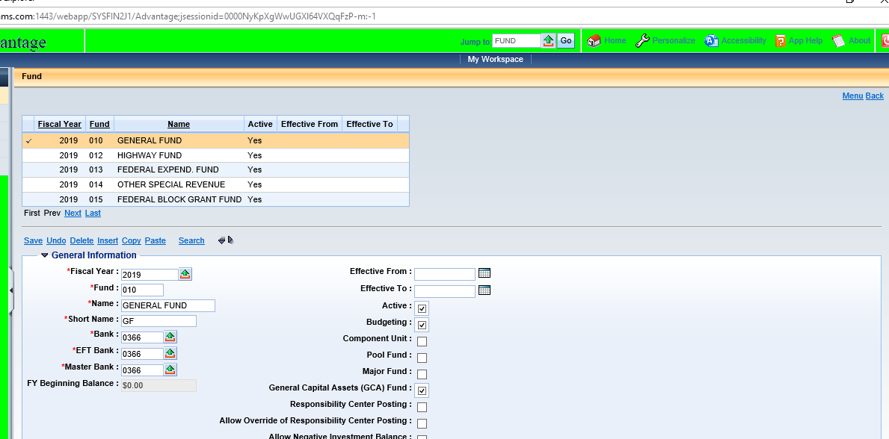

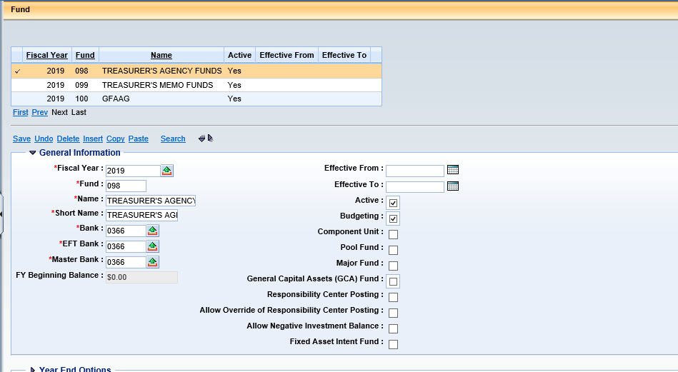

UNIT

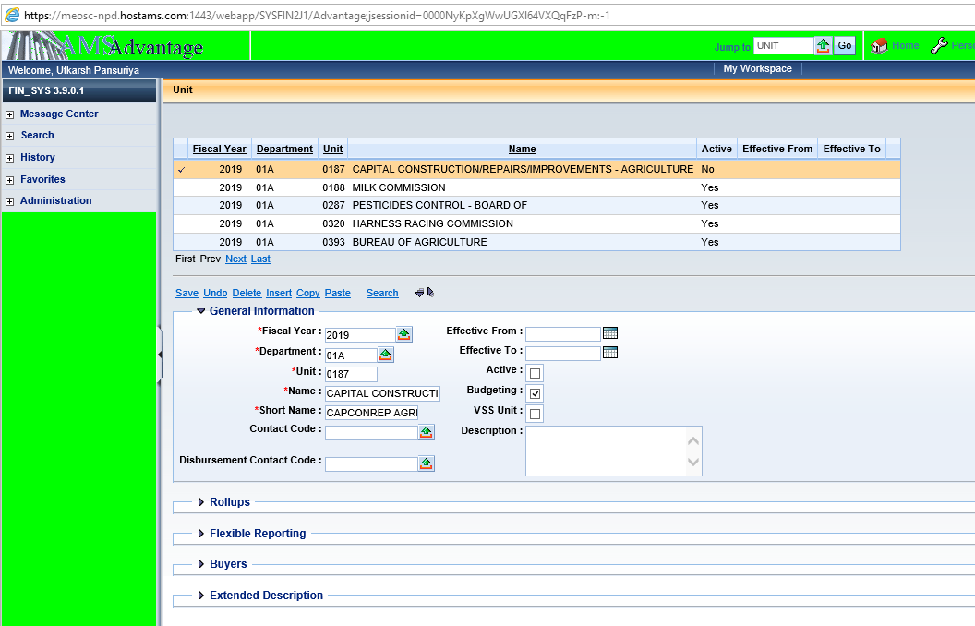

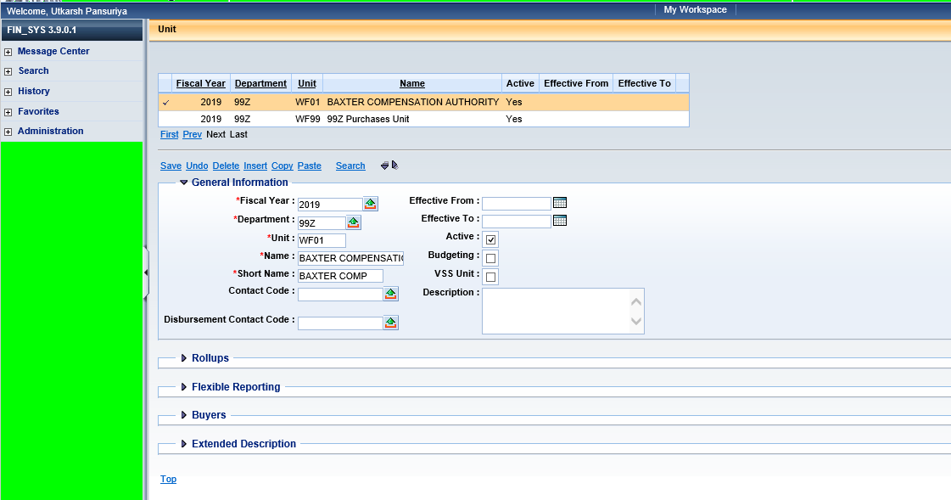

Sub Unit

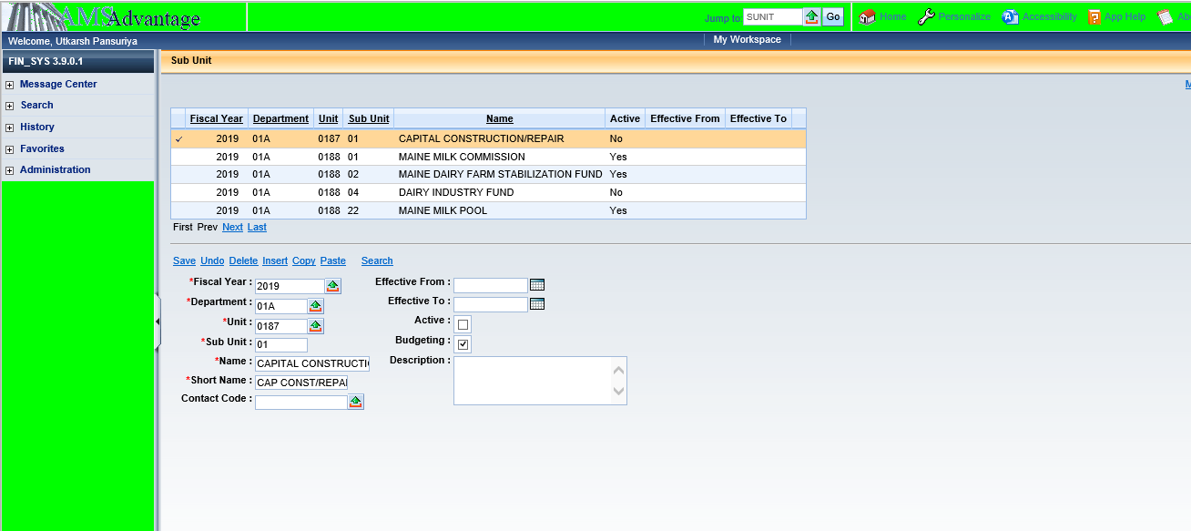

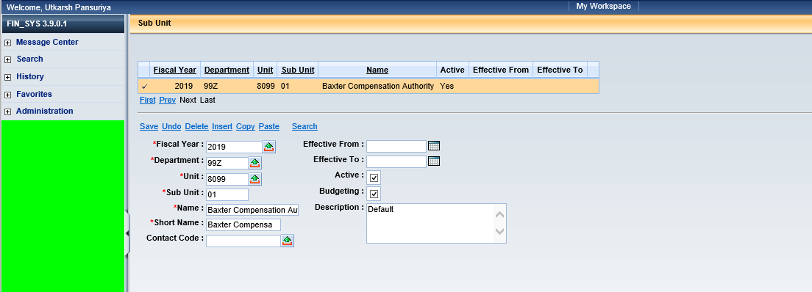

ADNT

